**Experiment No # 02**

**Demonstration Of Two Stroke Petrol Engine**

**Introduction:**

* **Two Stroke:**

A **two-stroke** (or **two-cycle**) **engine** is a type of [internal combustion engine](https://en.wikipedia.org/wiki/Internal_combustion_engine) which completes a power cycle with two strokes (up and down movements) of the [piston](https://en.wikipedia.org/wiki/Piston) during only one crankshaft revolution.

* **Petrol Engine:**

A **petrol engine** (also known as a gasoline engine) is an [internal combustion engine](https://en.wikipedia.org/wiki/Internal_combustion_engine) with [spark-ignition](https://en.wikipedia.org/wiki/Spark-ignition_engine), designed to run on petrol ([gasoline](https://en.wikipedia.org/wiki/Gasoline)) and similar volatile fuels.

**Process:**

* Intake.
* Compression.
* Power.
* Exhaust.

**Intake:**

The fuel/air mixture is first drawn into the crankcase by the vacuum that is created during the upward stroke of the piston. The illustrated engine features a poppet intake valve; however, many engines use a rotary valve incorporated into the crankshaft.

**Compression:**

The piston then rises, driven by flywheel momentum, and compresses the fuel mixture. At the same time, another intake stroke is happening beneath the piston.

**Power:**

At the top of the stroke, the spark plug ignites the fuel mixture. The burning fuel expands, driving the piston downward, to complete the cycle. At the same time, another crankcase compression stroke is happening beneath the piston.

**Exhaust:**

Toward the end of the stroke, the piston exposes the intake valve, allowing the compressed fuel/air mixture in the crankcase to escape around the piston into the main cylinder. This expels the exhaust gasses out the exhaust valve, usually located on the opposite side of the cylinder. Unfortunately, some of the fresh fuel mixture is usually expelled as well.

**Diagram:**

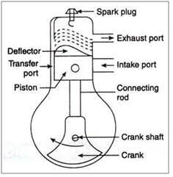

Fig no 2.1

**Parts of engine:**

1. Crank Case

2. Crank Shaft

3. Connecting Rod

4. Piston

5. Cylinder

1. Inlet Channel
2. Outlet Channel
3. Overflow Channel
4. Spark Plug
5. Carborator
6. Throttle Valve

**Explanation of parts:**

**Crank Case:**

Two-stroke engines typically use a crankcase-compression design, resulting in the fuel/air mixture passing through the crankcase before entering the cylinder. This design of engine does not include an oil pump in the crankcase

**Crank Shaft:**

The crankshaft design also establishes the length of the piston stroke because the radial offset of each throw is equal to the half of the stroke imparted to the piston.

**Connecting Rod:**

A **connecting rod**, also called a **con rod**, is the part of a [piston engine](https://en.wikipedia.org/wiki/Reciprocating_engine) which connects the [piston](https://en.wikipedia.org/wiki/Piston) to the [crankshaft](https://en.wikipedia.org/wiki/Crankshaft). Together with the [crank](https://en.wikipedia.org/wiki/Crank_(mechanism)), the connecting rod converts the [reciprocating motion](https://en.wikipedia.org/wiki/Reciprocating_motion) of the piston into the rotation of the crankshaft.

**Piston:**

Inside each cylinder is a piston that slides up and down, and as it does so, it turns a crankshaft that's attached to a gearbox, which in turn powers the car's wheels. The cylinders are also equipped with valves that let in air and fuel, and allow exhaust to escape.

**Cylinder:**

Most small two stroke petrol engine cannot be lubricated by oil contained in their crank case and pump,since the crank case is being used to pump air fuel mixture into the cylinder.More recent two stroke engines pump lubrication from a separate tank of two stroke oil.

**Inlet Port:**

The inlet port is connected to transfer passage leading to the fully enclosed crank case. A spring loaded inlet valve admits air into the crank case on the upward or compression ,stroke of the piston. Air trapped into the crank case is compressed by the descent of the piston of the power stroke.

**Outlet port:**

The [outlet valve](https://www.sciencedirect.com/topics/engineering/outlet-valve) is given a lead in opening before the piston reaches bottom dead center on the power stroke. Thus the [burnt gases](https://www.sciencedirect.com/topics/engineering/burnt-gas) are already leaving the cylinder under their own pressure as the piston begins its exhaust stroke. As a result, the engine expends less energy on expelling the exhaust gases than would otherwise be the case.

**Overflow Channel:**

The invention relates to a two-stroke engine having an overflow channel through which an air/fuel mixture is supplied. The overflow channel is provided with a vaporization chamber having a hot wall against which fuel is injected and vaporized. The vaporized fuel is stored in the vaporization chamber and is carried into the combustion chamber of the engine by fresh air flowing in from the crankcase when the overflow channel is opened.

**Spark Plug:**

In Dual **Spark** ignition **engine** has **two Spark plugs** located at opposite ends of the combustion chamber and hence fast and efficient combustion is obtains. The benefits of this combustion process can be felt in terms of better **fuel** efficiency and lower emissions. Dual Sparkplugs used for faster and better combustion.

**Carburetor:**

A carburetor is a device that mixes air and fuel for internal combustion engines in the proper air–fuel ratio for combustion.

**T-S Diagram:**

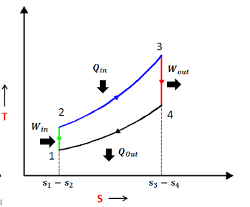

**P-V Diagram:**

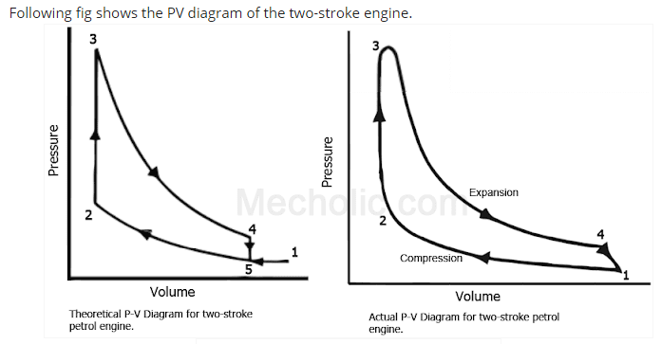

**Lean Mixture and Rich Mixture:**

The key difference between lean and rich mixture is that we use lean mixture for maximum efficiency and we use rich mixture for maximum power in an engine.

Lean mixture has more air than the required quantity of air for complete combustion of fuel. On the other hand, rich mixture less air than the required quantity of air for complete combustion of fuel in engine.